**Top 50 apps for iWatch**

The top brand for electronic devices with most luxuries is Apple. Apple has a range of products and iWatch is another luxury offered by Apple with variances in design, colors, functionalities, and compatibilities with each of its new releases. Apple’s iWatch helps to stay healthy and intact with your phone and devices connected at the same time. It helps monitor the heart-rate, track the exercises, listen to songs and take up the calls, all at the same time.

With a wide range of services to provide a modish experience, iWatch has various applications to be installed and optimized for enhanced experiences. There are several applications available, but the crucial decision is of the selection of the perfect one for the download. While several applications present are free for installation and usage, a few of them also come with a price tag. Here, we are going to get an in-depth view of the top 50 applications that are a must for every iWatch user for amazing experiences.

1. **ETA**

Navigating around the places and moving from one place to another is less hectic and tiring with the help of this application. ETA is personal assistance that provides access to the traveling times and driving directions to all the destinations by analyzing the traffic along the routes and directing towards the shortest available route. This is a simple application with an easy interface to navigate around the cities and is available on iWatch. ETA is the application that works in the background with GPS tracking simultaneously along with the other application usage.

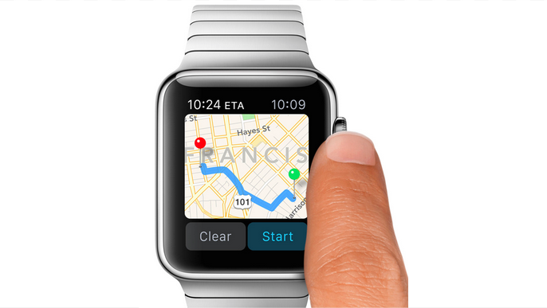

1. **iTranslate Converse**

Traveling and moving around the countries is a lot more interesting and amazing with iTranslate Converse. This application helps you convert any language to your native language, and you just have to select the languages to switch in between. This application is easy for accessibility and has a simple interface, and apart from that, it provides excellent accuracy with fast translations and covers around 38 languages available worldwide.

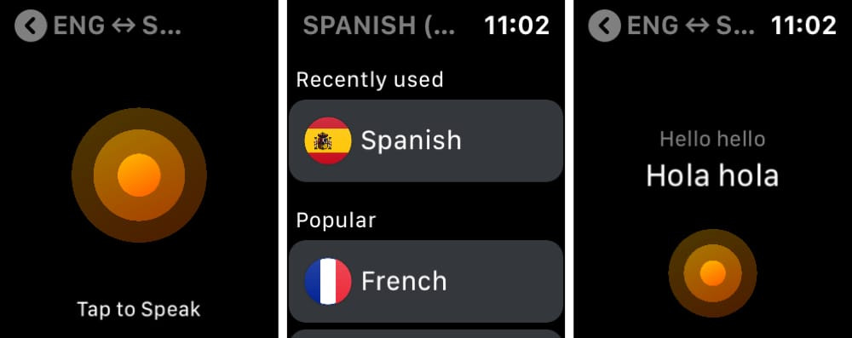

1. **App in the Air**

App in the Air is another free application with various in-app purchases available for iWatch. This is a traveling assistant that helps to track the flights and provide various instructions for the flights. It helps to stay safe and relaxed during the travels complication and timetable supports are also there to ease your task and get whole information about the journey.

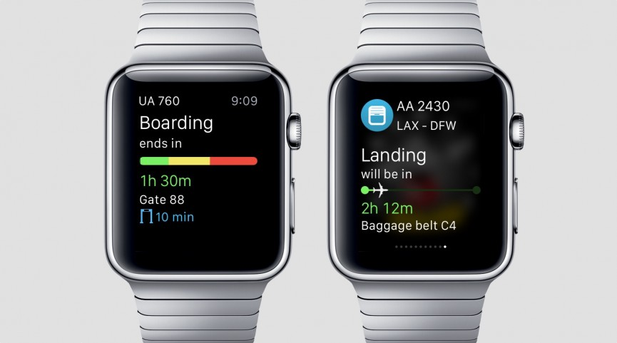

1. **Currency**

Currency is the best application available for converting currencies. It has about 160 currencies and countries installed with up-to-date exchange rates. This is the best application that is available for any traveling lover. It provides the ease to check the currency rates with just some clicks without any searching and loss required. This is an old application that is available in iWatch for a few times now and has a simple interface.

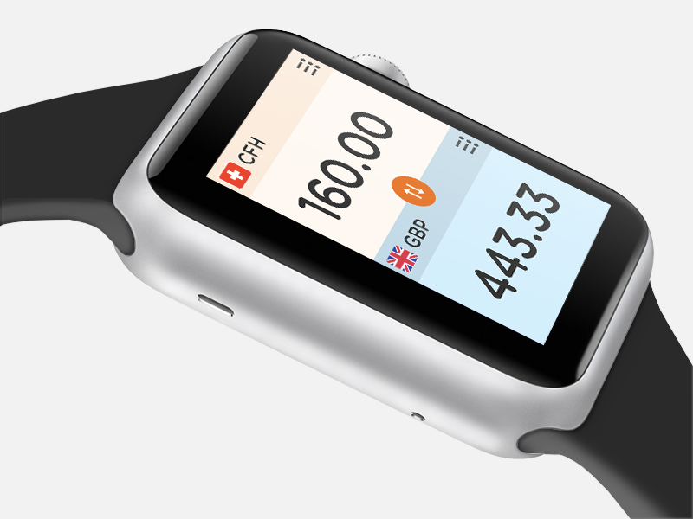

1. **Strava**

Strava is an application that is the best application for fitness freaks. It has a GPS tracker for keeping a track of your running and cycling. For the people who want to stay fit, or want to have any practice for running and athletics, this is the best application available with iWatch. And, this can also be used without the need of an iPhone which makes it a standalone application.

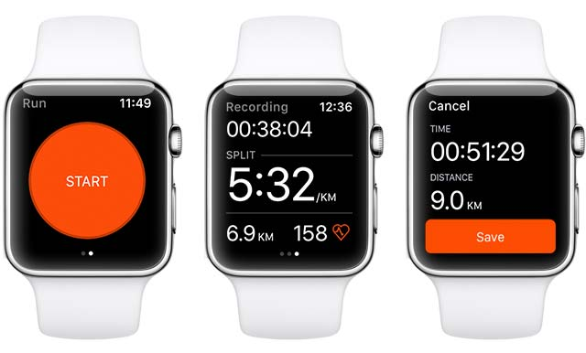

1. **Pear**

Pear is another fitness application that is free in iWatch and has a few in-app purchases available for enhanced experiences. It has a personal coach application facility that helps provide interactive experiences. While any workouts, morning walks, or covering any routs, or doing yoga, relates to the specialist of the field who will help you motivate through personal stories. It is a customizable app so you can choose your final goal and what is your requirement with the exercises and workouts.

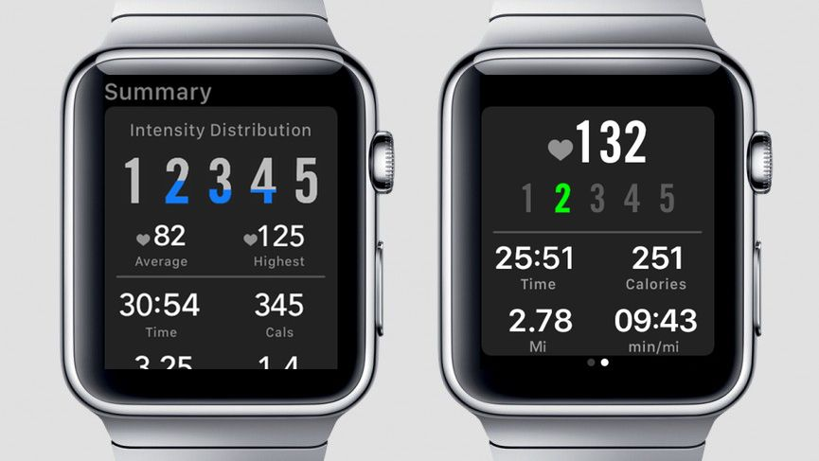

1. **ActivityTracker Pedometer**

This application helps to tracks the steps, calorie burns, and other workouts to keep records of your daily activities. ActivityTracker is the best application to stay fit and maintain your health and workout. This tracks all the daily activities without any GPS requirement and provides a history of per hour of the exercise during the day. Also, coming in the iWatch makes this application widely used due to easy handling and simple accessibility.

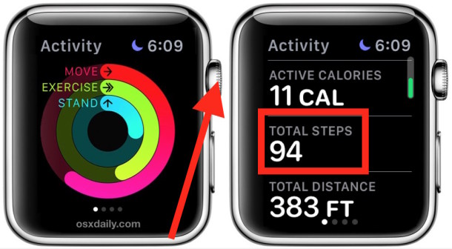

1. **WorkOutDoors**

This is not a free application and charges $5.99 for installation in the device. This provides a map feature that can be zoomed in to check the route to be traveled due during any workout and exercise. This also helps to analyze the distance wise training taken. The map is scrollable and rotates automatically according to the movements. This is the perfect application available for the iWatch users to navigate the ways during the hardcore runnings and other exercises.

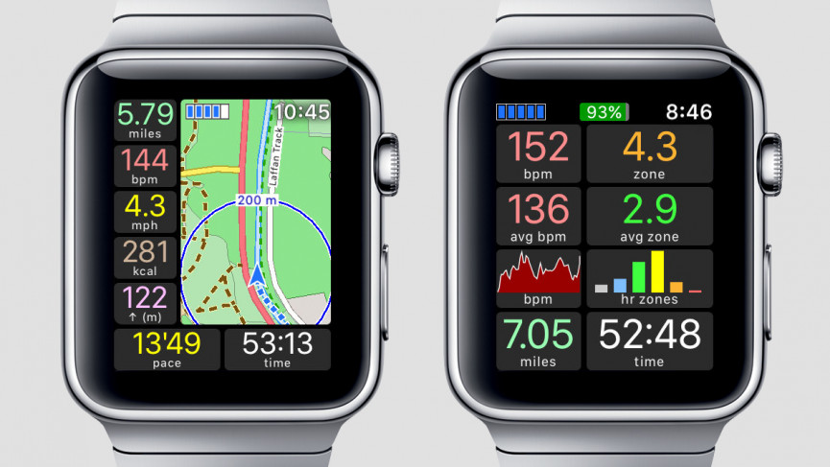

1. **ViewRanger**

ViewRanger comes free in iWatch along with some in-app purchases available for more fascinating app experiences. This provides information about hiking and cycling trails and routes that are available worldwide. For adventure lovers, this is the perfect application that has various navigations for trekking and. Added topographical map features are available with the in-app purchase to provide deeper information about the trails and the routes.

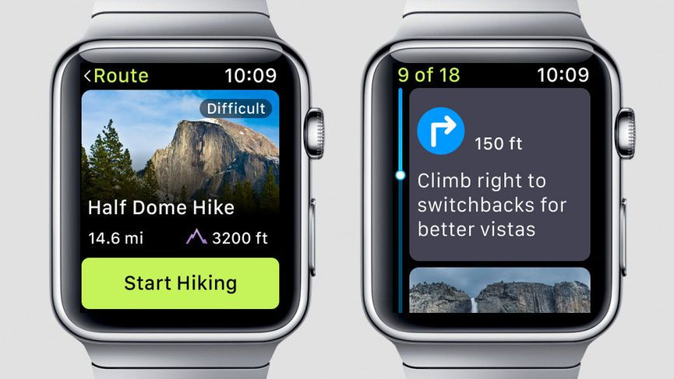

1. **Streaks Workout**

Streaks is a paid application and charge $3.99 for the installation and downloads. This is the fitness application that is the best one to stay focused and motivated towards your exercise and workout goals. You can set the exercise and duration according to your requirements in this app. From quick workouts to tough and extreme hardcore exercises, this application is perfect for beginners as well as advanced workout lovers. From staying fit, to gaining muscles, everything is possible with Streaks Workout.

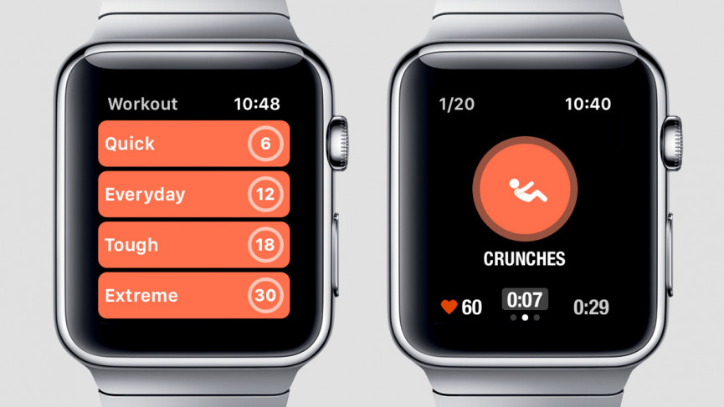

1. **Carrot Fit**

Coming at $3.99, Carrot Fit is a paid application and is a 7-minute workout application that is the best for the quickie exercises for busy schedules. This has various exercise techniques including even the dance for staying fit and maintaining health. You can check the workout progress in the watch at your risk that supports this application. You can also touch to stop the progress or check the instructions for the exercise.

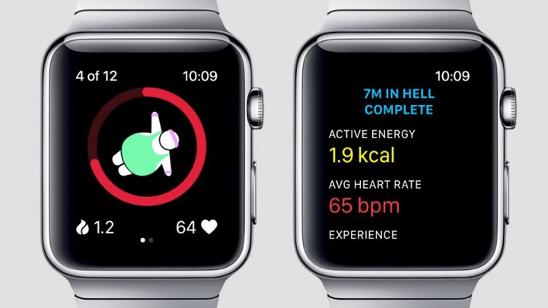

1. **Zones for Training with Exercise Intensity**

People who want to take training and workout while maintaining a track of their heartbeat can have the right experience with ZTEI. Various workout modes are there from walking and running, to heavy exercises, and this will keep the track of the heart rate during the meantime. This then transfers the data to the Health app. This is a free-to-use application that increases its usability further.

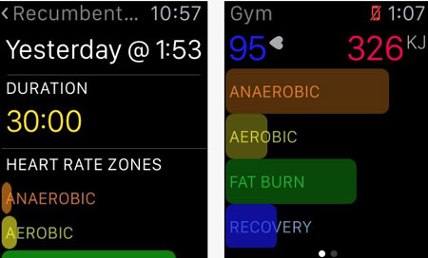

1. **RunKeeper**

RunKeeper is a free application that is available for Apple watch. With this, handling the phone while running is so much easier as there is no need to carry your phone and you can just keep a track with your watch. There is also a little heart rate chart available on the watch and you can get a statistic of your running just after the completion of the workout at your screen.

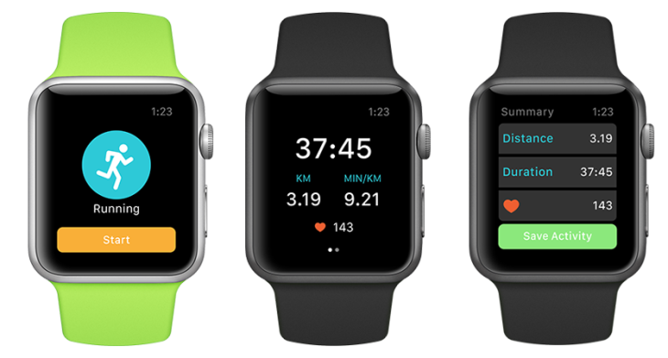

1. **Slopes**

Slopes is the application that is available with various in-app purchases, and other than that it comes with free installation. It has detailed information about the speed, altitude, and distances that you have covered while walking or trekking around. Slopes helps record the data with the help of the iWatch providing detailed statistics on your watch screen and no need of carrying the phone along with you.

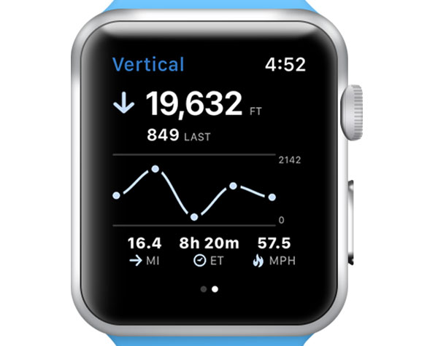

1. **Air Matters**

Air Matters is the best well-being application that is provided in the Apple watch with free installation and download. This is a weather app that can track and provide real-time updates for any weather condition and complication expected. Also, basic weather forecasting is available along with the particulate matter levels as displayed on the screen. This provides information about how pure the air is and is it beneficial to inhale that outer air or would it be an allergy caused to you later on!

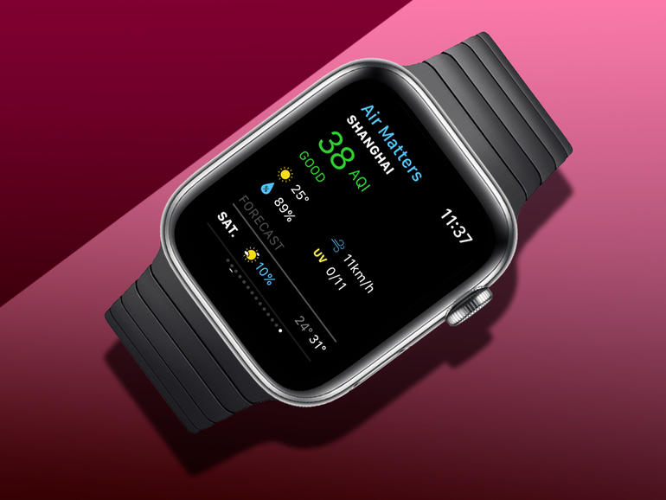

1. **Heart Analyzer**

Heart analyzer is the application that keeps track of your heartbeat during any hardship or exercise timings. It draws all the health data and presents it interactively to get you the information about every brief thing workout statistics. This is a free application with in-app purchases. And, with this application, you can get the matrix of heart rate over the past weeks and about the present exercise sessions.

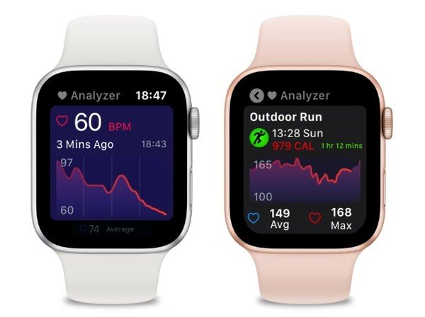

1. **Streaks**

Streaks is not a free application, it charges dollar 4.99 for its usability. However, this is one of the best applications available on iWatch for well being as it has a track of all the self habits and various timely tasks are available according to your requirements. Customization is provided too and they are divided around the week or the month according to your schedule. It is a flexible app and provides track tasks, run timers, and marks everything on the display.

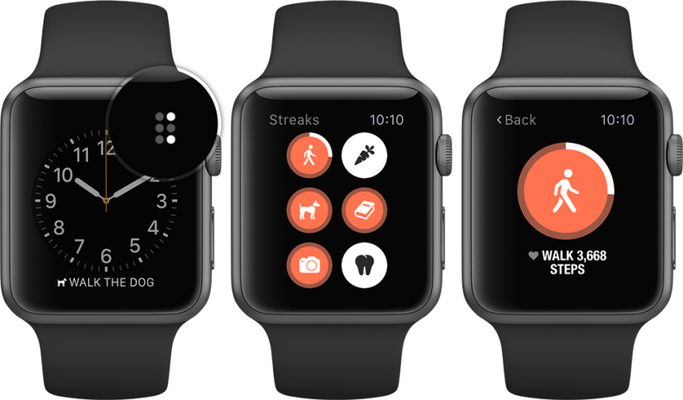

1. **Moodistory Mood Tracker**

This mood tracker comes with a price tag of dollar 4.99 from iTunes. This provides a facility to save your mood swings and everyday experiences whether you are happy, sad, shocked, or whatever it is and keeps track of the records to help you analyze your mental status. This can help to create a journal entry and figure out your everyday mood swings. Up and down graphs are available on the screen provided by the iWatch to get easy understanding.

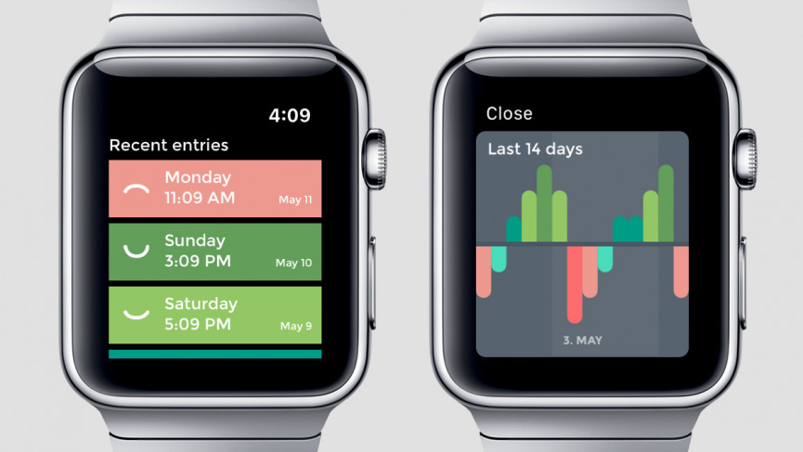

1. **One Drop**

One drop is a free application that is provided by iTunes, and it is the best application for diabetic patients that keep the record of the glucose intake, Calories, and sugar levels. It helps to analyze the food intake and the nutrients and glucose intake according to the meals along the day. This helps to manage diabetes in the best possible way ever.

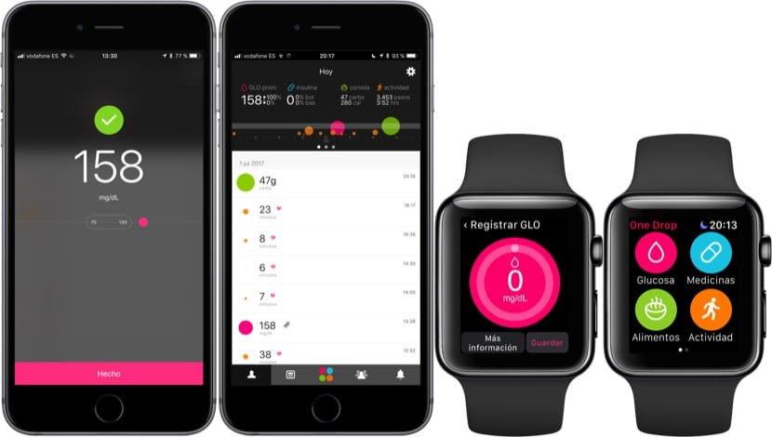

1. **AutoSleep**

Auto sleep is an application that is provided by iTunes for Dollar 3.99. You just need to sleep while wearing your watch and it will automatically track your sleep and shows the analysis in the morning or whenever you wake up. It shows everything including how restless you were, how peaceful you were, how much time you were asleep, and how much time your sleep broke.

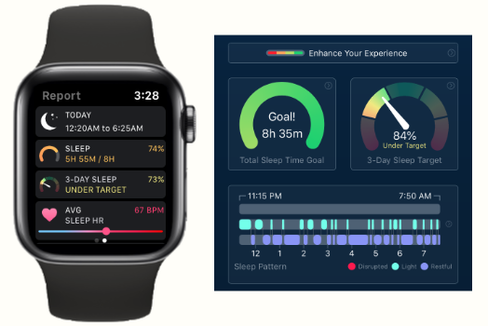

1. **Vekt**

Vekt is also a paid application for a dollar 1.99. This helps to keep track of your weight and this is an easily accessible application that is there for everyone from a beginner to the ones having advanced knowledge about the application handling. You just have to input the details and that is a lot easier, just save the weight, and you are done! This also directs you towards your goals and helps you get an analysis of how much effort is required to achieve that by keeping a record of everyday practice.

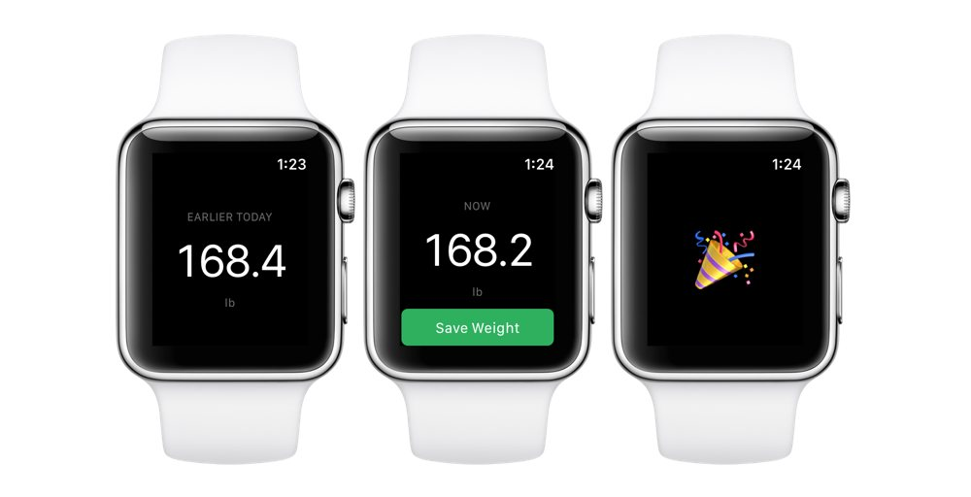

1. **Start With Yoga**

Start with yoga is the best relaxation app and is one of the great mindfulness application that is available in iWatch for just dollar 2.99. Yoga is the best exercise and way for a peaceful and calm mind, and to stay focused along with maintaining health. This app also helps to remove distractions and helps focus on the simple sceneries with the help of static images. You can customize the app by defining the time limit for each exercise and decide your routines.

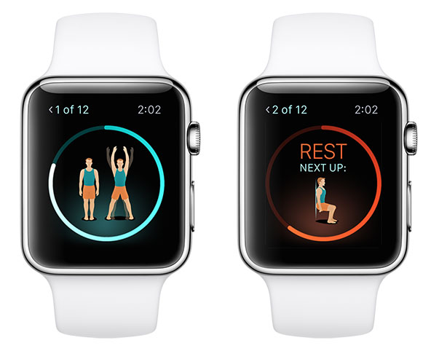

1. **ESPN**

ESPN is a free application that is provided by iTunes for Apple iWatch. If you are a sports lover and do not have much time to see the sport matches or are you busy with your meetings, then ESPN is the best application you can use. You just need to choose the team and the sport and all of the record is available at your watch. It provides various news alerts and complications that you need to know about your favorite sport that you are missing!



1. **Just Press Record**

Just press record is a page application for Dollar 4.99. This is an effective application for making quick recordings as its name suggests. You just have to tap the button for recording and stop the records with another tap, and the recording is perfectly done. You can also save the application with the cloud with this app, and hence you can assess the audio any time and at any device.

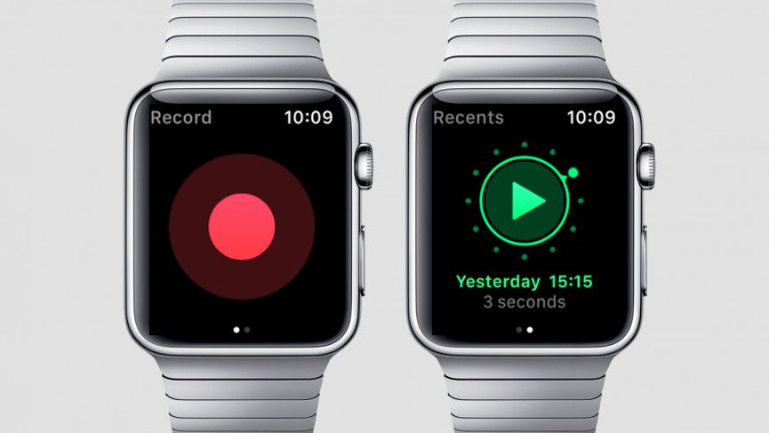

1. **PCalc**

PCalc, however, is a bit costlier than the other ones as it comes with the price tag of dollar 9.99. However, this is the most useful application having a calculator, Currency Converter, and advanced calculating features available. This is highly interactive and responsive and provides accurate data for any conversion or calculation with 100% efficiency.

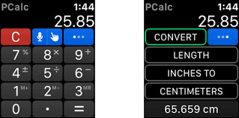

1. **FlickType Keyboard**

There are many applications available for text to speech, but the FlickType keyboard is provided by iWatch with a full QWERTY keyboard for a cost of 2.99 dollars. This app is highly friendly once you master the small touches required in the application. This is the faster feature provided among all the other options.

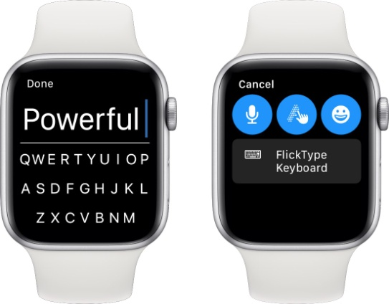

1. **When Do – A Complication**

When Do – A Compilation is also a paid product, but it is a cheaper one with only 0.99 Dollars required. This is the best one to save all the reminders for any anniversary, birthday or any other special day that you do not want to miss. And, this is just like a cheat sheet that is available at your wrist, and it gives the countdown and the details about every special occasion at the right time. This application saves you from forgetting anything special!

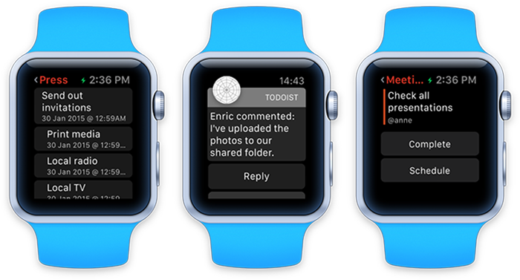

1. **Mint**

Mint is a free application that is provided by iTunes and this is the best application to keep a track of the bills that are the most hectic things in anyone's life! It keeps the track of all the old bills as well as the upcoming ones that you are required to pay soon. And, it also carries information about your credit score and the money transactions. All these financial Essentials can be handled with the help of this application with quick slides available, and this is a simple and neat application so you cannot confuse between the services.

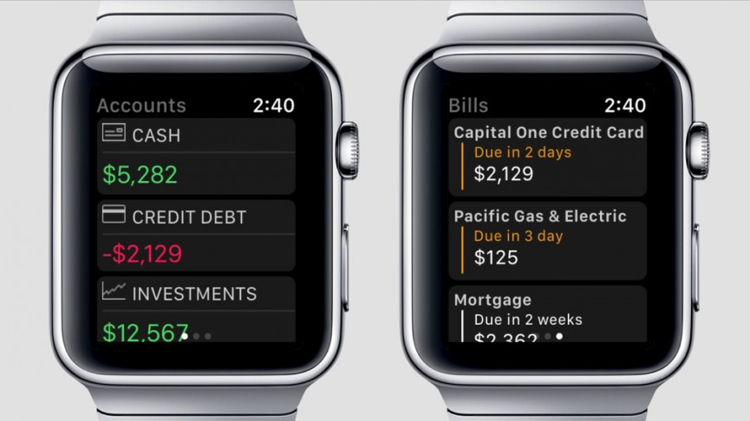

1. **Fantastical**

Fantastical is a paid application at dollar 4.99 and is just like a calendar app for keeping the reminders about appointments, saving the special days, events, and much more. It has a natural language input required so you can correctly get the reminders and understand what it is about. This is the best product for any iWatch users with its simplicity and detailed feature.

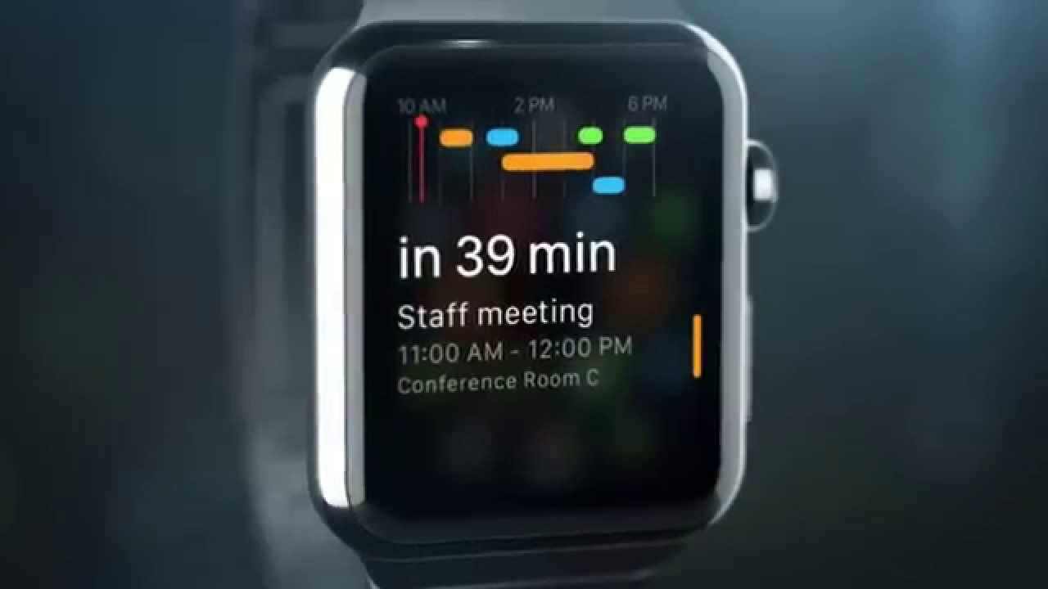

1. **MultiTimer**

MultiTimer is a free application for some devices and it comes with a price tag of dollar 5.99 for in-app purchases. When most of the countdown timers come with unlimited accessibility of only one countdown, this can handle multiple countdown timers simultaneously. Also, it can handle about 6 timers in its free version itself, and with the paid version the limit increases for an unlimited timer.

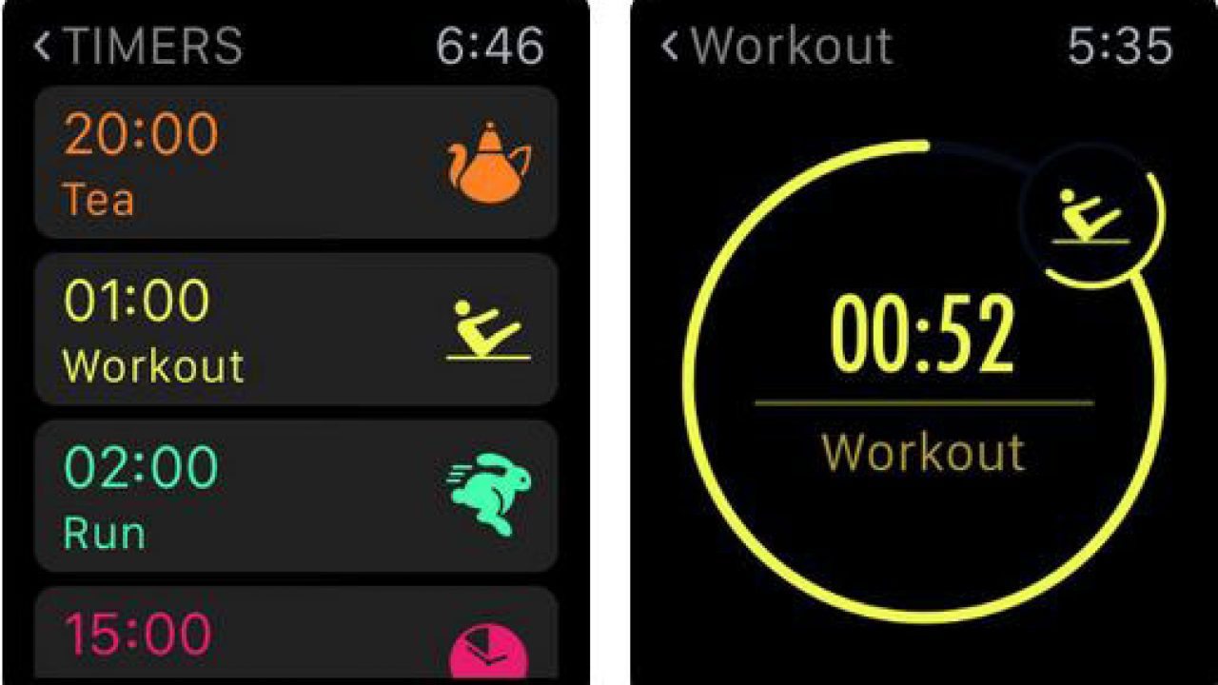

1. **Pennies**

Pennies is a paid application for Dollar 3.99 that is provided by iTunes if you need to keep track of your transactions, all the expenditures, and the money left in the budget expenditure. This is the best application that you can have access to in iWatch, and the list feature is available where you can add and remove funds and discover the final amount left in the budgets. It is widely used because of its accessibility over the watch.

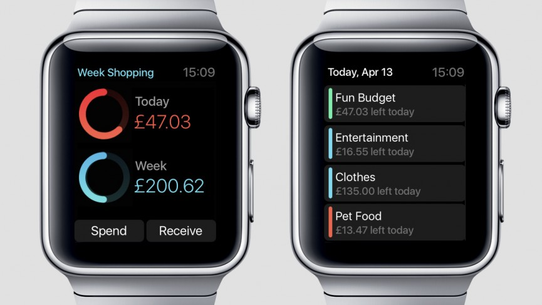

1. **Deliveries**

Deliveries are the best application for dollar 4.99. If you have ordered anything recently or waiting for any delivery, then this is the best application to track the orders and ensure that the courier arrives on time and at the correct place. This gives details without the need for any phone or laptop required for tracking with the same list, location maps, and details provided. In the iWatch, it also shows a notification when the item is about to be delivered.

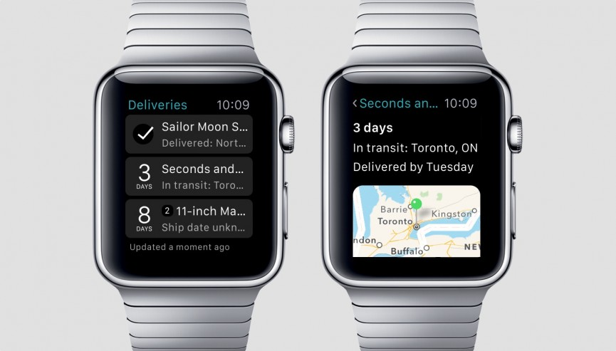

1. **Chirp for Twitter**

Chirp for Twitter is a free application having some in-app purchases available for enhanced accessibilities. With this, you can have all of your Twitter timeline available at your wrist and there is no need to carry any other device to get access to the account. You can check the tiny messages over the watch, trending posts, and mention people; and with the in-app purchases, it unlocks the full set features enabling you to reply to those messages, perform searches, and keep track of all the news available that is trending.

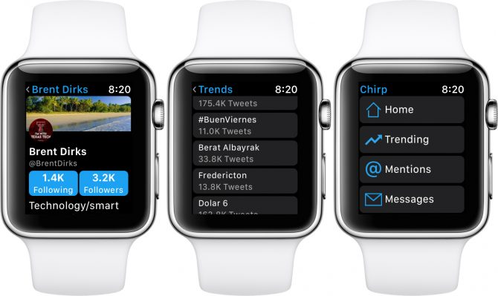

1. **Things 3**

Things 3 is a paid application for $9.99 that is a bit costlier than the other ones. This is like a to-do list that reminds you about the everyday details, the events, and the activities that you have to carry along in the day. It organizes your entire life and sort the items according to the days, like, for today, upcoming, and anytime news. It focuses mainly on the current task that is required more, and you can also tick the completed ones.

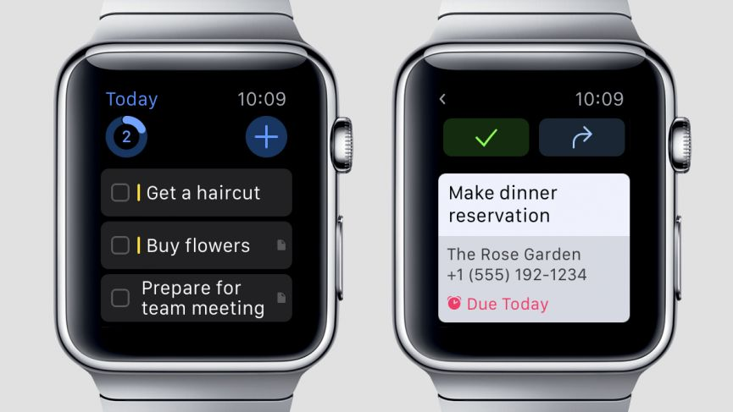

1. **Authy**

This is an authentication app that has free access, simple and easy interface, and a cloud support system for secure data saving. This is the best app that is available on the iWatch for cyber safety and security of the data from any attack or hacks. This app provides 2-factor authentications that are more reliable than the normal password and ID securities for the devices. The app verifies the identity every time you open and hence saves the data online.

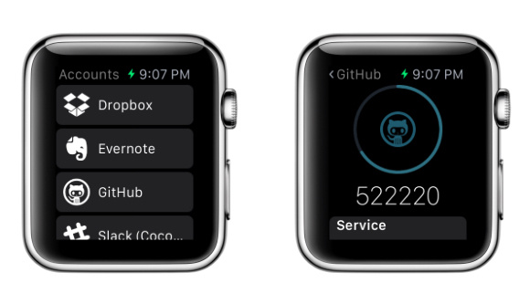

1. **Messenger**

Accessing your Facebook account and the chats with your friends is much easier with Messenger on iWatch. This is a free application with a full Facebook chat system with big bold characters and icons for better vision. This provides ease in chatting with friends in real-time with various emojis and stickers supported. Replying and having wide talks and gossips with chats are awesome with Messenger.

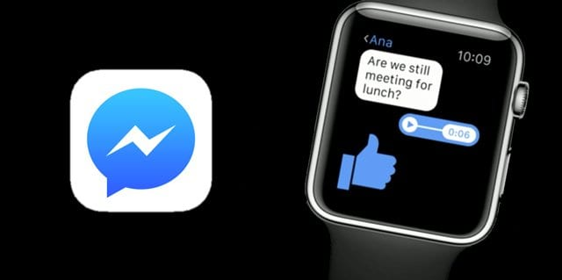

1. **V for Wikipedia**

What about searching and surfing the browsers for various information? Now there is no need to carry whole big Smartphones and the devices, as there is V for Wikipedia supported in iWatch. The interface is a bit small but covers all the knowledge with the right information and smart detailing. The app also allows bookmarking the pages to select the information to be accessed anytime, and the app does not require the phone and can work on its own in the watch. The app charges $5.99 for usage.

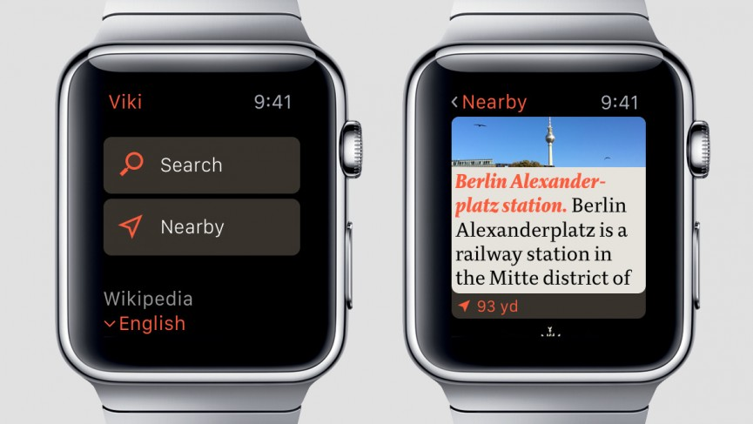

1. **Dark Sky**

Dark Sky is a paid application with a charge of $3.99 and is the best and attractive app with various icons and images to provide the weather information with interactivity embedded in it. Rainfall graphs are available on the wrist with this application to properly plan your trips and outings without any issue of worrying about the climate and weather. You can see the forecast for each day as well as for the whole week. This provides sweet interactivity with small and cute icons.

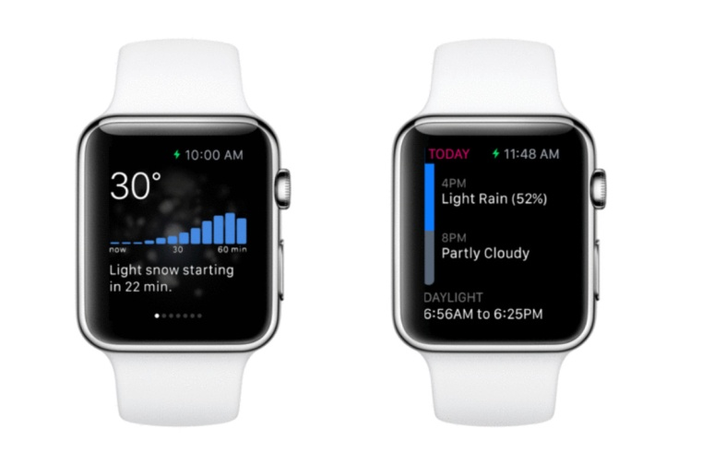

1. **BFT – Bear Focus Timer**

BFT is a paid application for 1.99 dollars. It has its entire working over the iWatch but is available on iPhone too. You can set the timer with this application with help of cartoon pictures and motivational images for happy experiences and good and beautiful reminders.

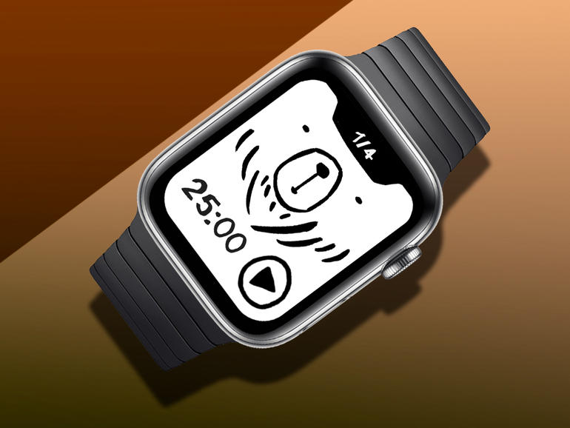

1. **CheatSheet Notes**

This is a free application and has several in-app purchases for Dollar 4.99 for enhanced features. With this, you can set the regular reminders that are important for every day but you might forget them because of the hectic schedules. It can save anything from passwords to meetings, names, dates, and every other detail. You can also save the entries by dictating them and assigning the icons along with them.

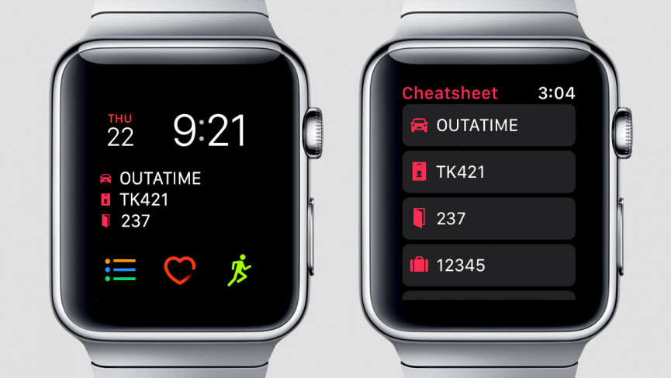

1. **Noted**

Noted is a free application with some in-app purchases available. It has a lot of voice memos to record the notes and you can also add the hashtags to the recordings. This is just like an audio bookmark and is the best one to create the notes. This is a handy note-taking way because of its accessibility on the iWatch that makes it better and recommendable for recording lectures and meetings.

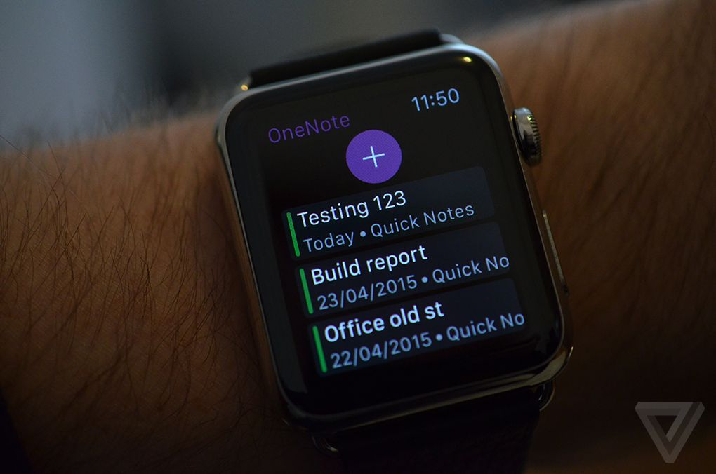

1. **Focus**

This app charges a dollar 4.99 per month for its accessibility on the iWatch. It helps to enhance the focus and stay committed towards your work by providing various sessions for different activities. It starts yelling at you in case you get distracted because of anything else and try to open up anything else on the watch. The application hence ensures your complete and un-diverted focus on any activity for the decided periods.

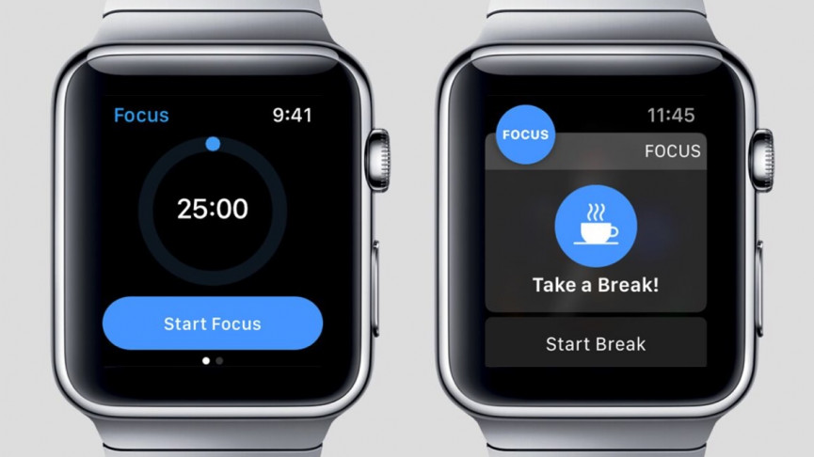

1. **Drafts**

Drafts is a free application to save all the important text and bills. This provides a service for note-taking and sharing the data, capturing the text in the inbox, and attaching them with any other, or archive or deleting the tag that is already added. It can also sync the data to your phone for anywhere accessibility.

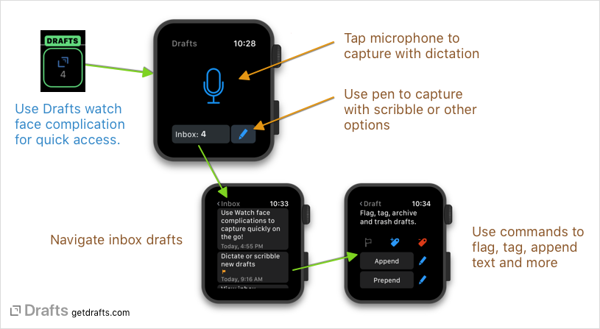

1. **Clicker**

This is an app that is available for iWatch for free and provides a simple interface for enhanced usage. After the launch is done, you just need to tap to increment a number and force touch to subtract or start from scratch. This is the best application to make a count of anything including any day, any object, or any workout that you need to keep a track of and save it for further assistance.

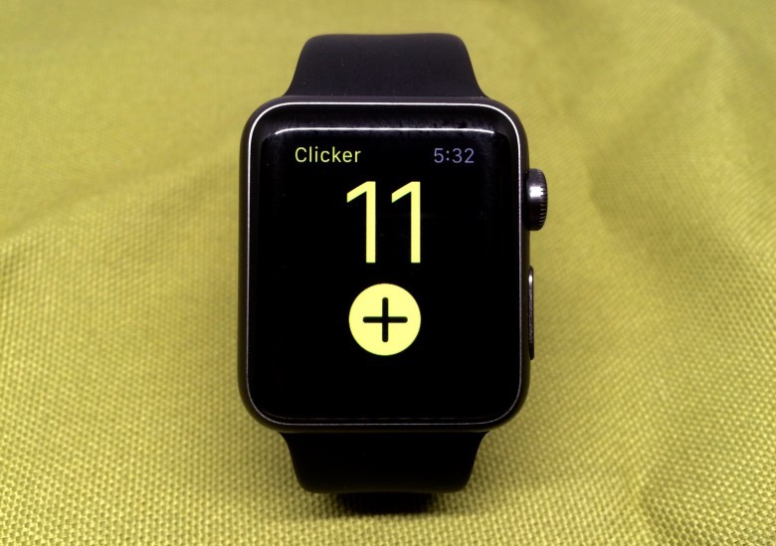

1. **Rules!**

The most essential applications that any device can support are entertainment games. Rules! is an application that is a paid one and comes for dollar 2.99. It provides various challenges every day that need tapping and time management, and are the hyper-casual techniques. This application helps to enhance your reactions to anything and any incorrect tap leads to the ending of the game. There are many levels available for entertainment!

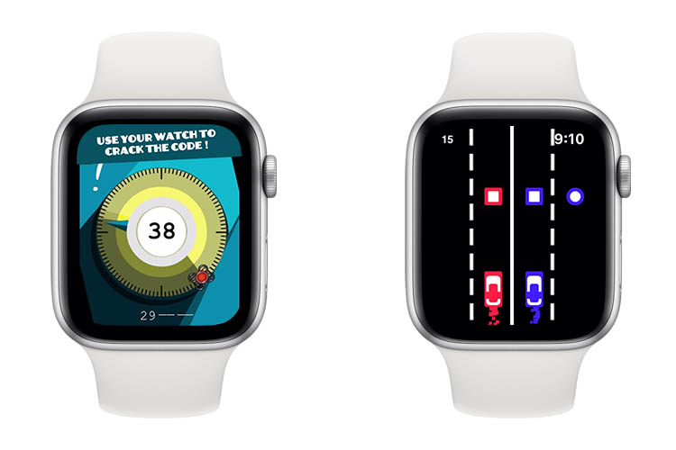

1. **MindKeeper**

This is the best gaming application that is provided by iWatch for just $ 1.99. This is a 3D game full of horrors, running activities, and you can spend a great time buy arming yourself just with the torch instead of any powerful weapon. There are various secrets, keys, and massive traps for the better gaming experience.

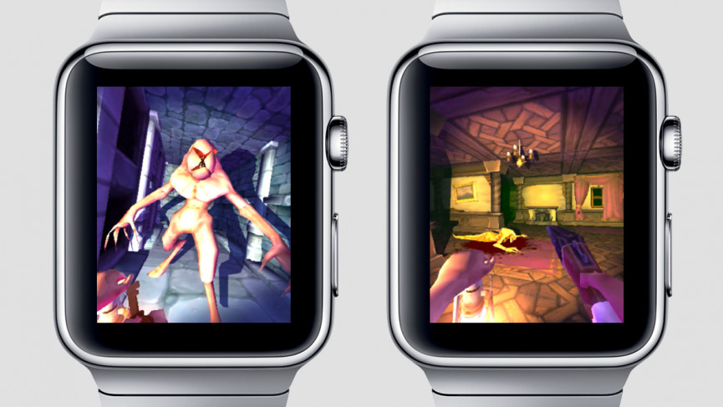

1. **Night Sky**

This is a free application that is provided on iWatch for better entertainment and time-pass. You just need to focus the device towards the sky and focus on the stars that you are looking at, and then you can get information about the sky, stars, and excel in the shiny things over the sky!



1. **Overcast**

Overcast is a free application that is provided by iTunes for accessibility over iWatch. This is used to podcast any player and it has various features like shifting to the next one, moving back to the previous one, increasing the voice, lowering the audio, playing, and pausing. This is the best one when you have to go out without your iPhone so that you can have access to the audios and sounds.

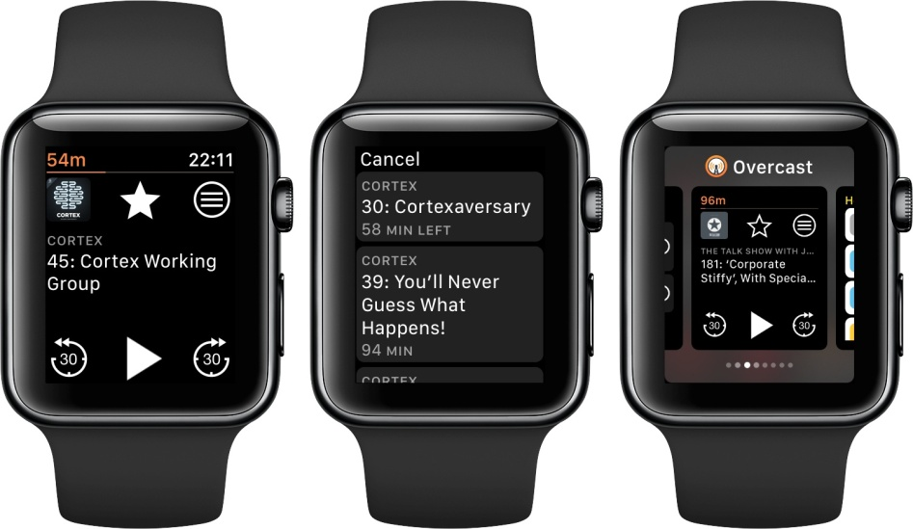

1. **Shazam**

Shazam is the best application that is provided on iWatch and is free to use application. If you also love listening to music but get confused with their names, and their singers, or music composers, then Shazam is there for your rescue! You just need to waggle the phone when a song is played, and the app will disclose every detail about the song as well as the lyrics, title, singer, music composer, and every other fine detail.

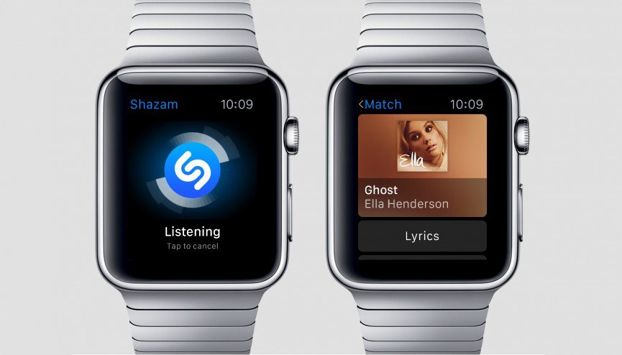

1. **Trivia Crack**

This is a free application that comes with a few in-app purchases. This is more like a quiz game where you can select any item out of the six available on the spin wheel, and there will be a question related to that particular item. The question will be related to the world concerning the selected object, and it helps to increase your general knowledge and IQ level.

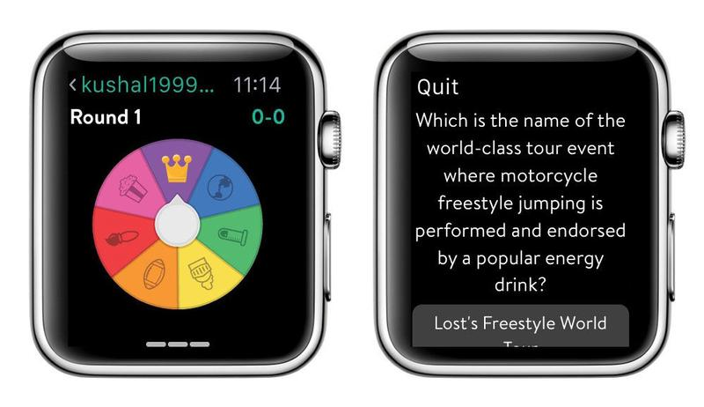

**Ending it up!**

There are many applications with variant uses like travel guides, fitness apps, health and well-being providers, mindfulness apps, everyday essentials, productivity apps, apps with entertainment, apps for chatting, and a lot more!

The above list is a blend of all the genres in the application and is the crucial one to have access to!